10.65: Taking the torque about the center of the roller, the net torque is 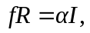 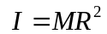for a hollow cylinder, and with 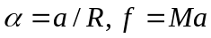(note that this is a relation between magnitudes; the vectors 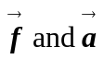 are in opposite directions). The net force is 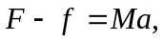 from which

